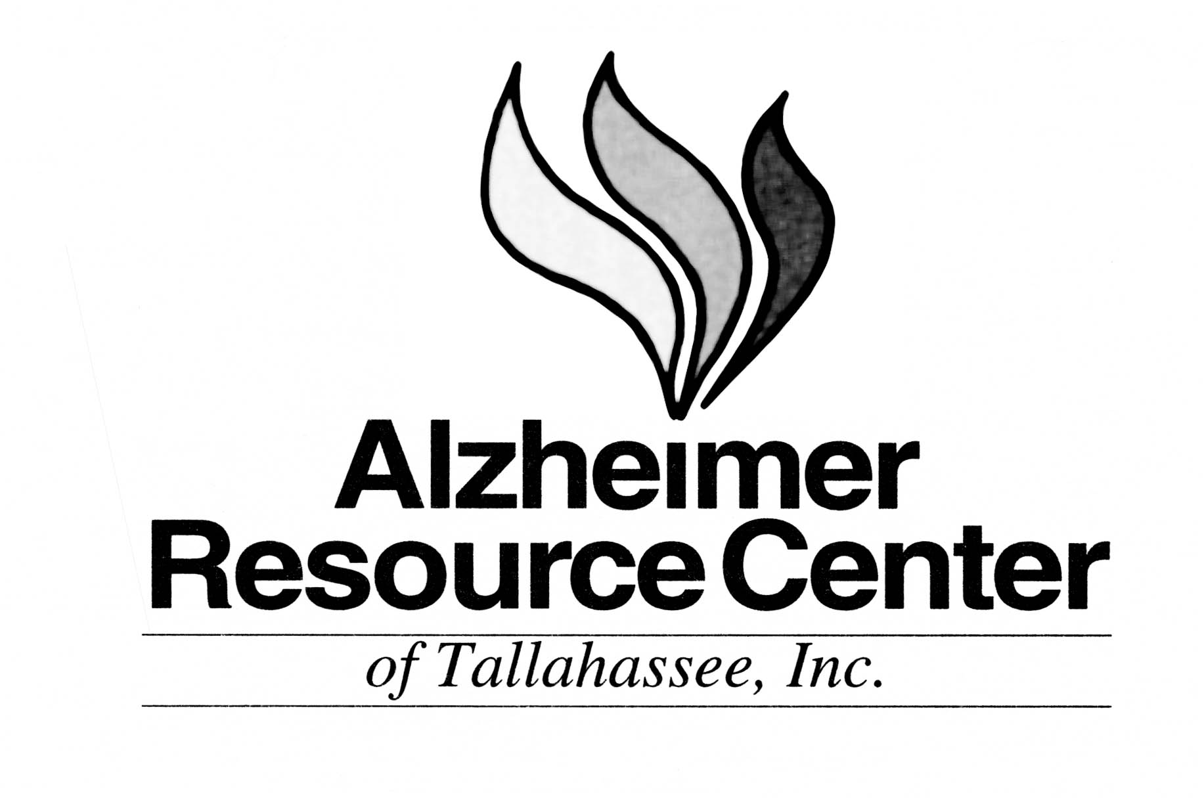

Prepared by the Florida Health Care Association with the assistance of the Alzheimer Resource Center of Tallahassee, Florida to meet the statutory requirement of 400.4785(1) (a) F.S.

ALZHEIMER’S DISEASE (AD) AND RELATED DEMENTIAS

History
Alzheimer’s disease (AD) was first discovered in 1906 by a German doctor named Alois Alzheimer. It is a disorder of the brain, causing damage to brain tissue over a period of time. The disease can linger from 2 to 25 years before death results. AD is a progressive, debilitating and eventually fatal neurological illness affecting an estimated 4-5 million Americans. It is the most common form of dementing illness.

Alzheimer’s disease is characterized clinically by early memory impairment followed by language and perceptual problems. This disease can affect anyone - it has no economic, social, racial or national barriers.

Causes
There is no one cause for Alzheimer’s disease. AD may be sporadic or passed through the genetic make-up. The disease causes gradual death of brain tissue due to biochemical problems inside individual brain cells. The symptoms are progressive, but there is great variation in the rate of change from one person to another. Although in the early stages of Alzheimer’s the victim may appear completely healthy, the damage is slowly destroying the brain cells. The hidden process damages the brain in several ways:

- Patches of brain cells degenerate (neuritic plaques)
- Nerve endings that transmit messages become tangled (neurofibrillary tangles)
- There is a reduction in acetylcholine, an important brain chemical (neurotransmitter)
- Spaces in the brain (ventricles become larger and filled with granular fluid)
- The size and shape of the brain alters - the cortex appears to shrink and decay

Understandably, as the brain continues to degenerate, there is a comparable loss in mental functioning. Since the brain controls all of our bodily functions, an Alzheimer victim in the later stages will have difficulty walking, talking, swallowing and controlling bladder and bowel functions. They become quite frail and prone to infections such as pneumonia.

Dementia vs. Normal Aging
As a person grows older, he/she worries that forgetting the phone number of a best friend must mean he/she is becoming demented or getting Alzheimer’s disease. Forgetfulness due to aging or increased stress is not normal aging and is not dementia.
“Dementia” is an encompassing term for numerous forms of memory loss. There are many types of dementia such as Alzheimer’s disease, Multi-Infarct dementia or Parkinson’s disease. When a person has dementia, he/she will lose the ability to think, reason and remember and will inevitable need assistance with everyday activities such as dressing and bathing. Changes in personality, mood are also symptoms of dementia. Many dementias are treatable and reversible. Alzheimer’s disease is the most common form of untreatable, irreversible dementia.

Alzheimer’s Disease - Stages of Progression
Alzheimer’s Disease can be characterized as having early, middle, and late stages through which the patient gradually progresses, but not at a predictable rate. The range of the course of the disease is 2-25 years. NOTE: Stages very often overlap. Everyone progresses through these stages differently.

First Stage: This is a very subtle stage usually not identified by either the impaired person or the family as the beginning signs of the disease. Subtle changes in memory and language along with some confusion occur at this time. The family usually denies or excuses the performance deficiencies at this stage.

- Forgetfulness/memory loss
- Impaired judgment
- Trouble with routines
- Lessening of initiative
- Disorientation of time and places
- Depression
- Fearfulness
- Personality change
- Apraxia (forgetting how to use tools and equipment)
- Anomia (forgetting the right word or name of a person)

Second Stage: As Stage 1 moves onto Stage 2, there is usually a particular significant event which forces the family (and impaired person) to consider that something is really wrong. At this time, they usually go to a doctor to diagnose the problem.

- Poor short-term memory
- Wandering (searching for home)
- Language difficulties
- Increased disorientation
- Social withdrawal
- More spontaneity, fewer inhibitions
- Agitation and restlessness, fidgeting, pacing
- Developing inability to attach meaning to sensory perceptions: (taste, touch, smell, sight, hearing)
- Inability to think abstractly
- Severe sleep disturbances and/or sleepiness
- Convulsive seizures may develop
- Repetitive actions and speech
- Hallucinations
- Delusions

Third (Final Stage): This stage is the terminal stage and may last for months or years. The individual will eventually need total personal care. They may no longer be able to speak or recognize their closest relatives.

- Little or no memory
- Inability to recognize themselves in a mirror
- No recognition of family or friends
- Great difficulty communicating
- Difficulty with coordinated movements
- Becoming emaciated in spite of adequate diet
- Complete loss of control of all body functions
- Increased frailty
- Complete dependence

COMMON PROBLEMS WITH DEMENTIA

Delusions
Suspiciousness: accusing others of stealing their belongings
People are “out to get them”
Fear that caregiver is going to abandon (results in AD person never leaving caregiver’s side)
Current living space is not “home”

Hallucinations
Seeing or hearing people who are not present

Repetitive actions or questions
They forget they asked the question
Repetitive action such as wringing a towel

Wandering
Pacing
Sundowning: trying to get “home”
Generally feeling uncomfortable or restless
Increased agitation at night

Losing thing/Hiding things
Simply do not remember where items are
Might hide things so that people don’t “steal” them

Inappropriate sexual behavior
Person with AD loses social graces and is only doing what feels good

Agnosia: inability to recognize common people or objects
A wife of forty years will become a stranger to the person with AD, he might even think she is the hired help
Might not recognize a spatula or the purpose of the spatula and/or cannot verbalize the name or purpose of the object

Apraxia: loss of ability to perform purposeful motor movements
Cannot tie a shoe or manipulate buttons on a shirt

Catastrophic reactions
(Causes) AD person often becomes excessively upset and can experience rapidly changing moods. The person becomes overwhelmed due to factors such as too much noise, too many people around, unfamiliar environment, routine change, being asked to many questions, being approached from behind.

(Reactions) AD person may become angry, agitated, weepy, stubborn or physically violent. It is best to attempt to avoid catastrophic reactions rather than dwell on how to handle them.

HANDLING DISTURBING BEHAVIORS

One of the most difficult challenges for caregivers is how to handle some of the disturbing behaviors that Alzheimer’s can cause. Symptoms such as delusion, hallucinations, angry outbursts, suspiciousness, failure to recognize familiar people and places are often the most upsetting behaviors for families. The following points may help in responding to disturbing symptoms.

First, try to understand if there is a precipitating factor causing the behavior. Were there household changes, too much noise or activity, was the daily routine upset? Time of day can also affect behavior (Sundowning). Being aware of these factors can help to better plan activities or anticipate problems.

- Keep tasks, directions and routine simple without being condescending
- Always give the person plenty of time to respond
- Attempt to remain calm and remind yourself that the behavior is due to the disease
- Avoid arguing
- Write down the answers to frequently asked questions, then remind them to look at the message
- Reduce environmental noise: television, radio, too many people talking
- Use distraction when unacceptable behavior starts: bring them into a different room, start talking about childhood or another favorite topic, show them magazines, ask them to help you do something like dusting or sweeping
- Do not overreact or scold for problem behavior: redirect or distract
- Be reassuring with touch, eye contact and tone of voice
- Find the familiar: old pipe, favorite chair, family pictures
- Avoid denying hallucinations: try non-committal comments like, “You spoke with your mother, I miss my mother too”
- Be sure to inform physician of hallucinations, no matter how tame
- Restless behavior or pacing is usually unavoidable, however you can make the environment safe by installing locks that are above reach, remove unnecessary obstacles, make sure the person is wearing some kind of identification

Alzheimer Resource Center of Tallahassee: (850) 561-6869 Website: www.arc-tallahassee.org
Alzheimer’s Foundation of America Website: http://www.alzfdn.org

